jQuery  
  
  
**Q1:-**  What Is jQuery?  
 **Ans. :-** jQuery is a fast, lightweight, and feature-rich JavaScript library that simplifies tasks like DOM manipulation, event handling, animations, and AJAX interactions. Below is a simple example of using jQuery to manipulate the DOM:  
  
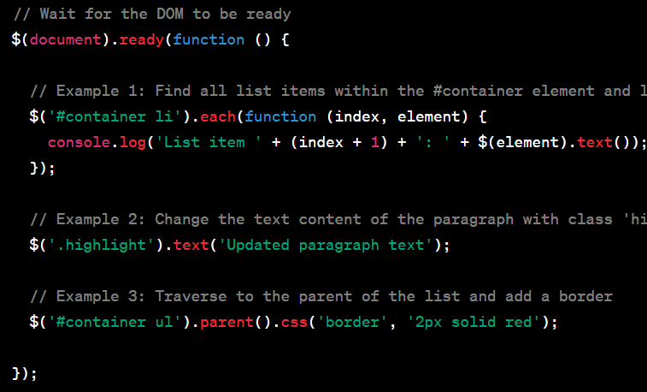

### Q2:- • How to Apply CSS Using JQuery, How to Add Class and Remove Class in Jquery, JQuery Animation? ANS:- 1. Applying CSS Using jQuery:

You can use the **css()** method in jQuery to apply CSS styles to HTML elements. Here's an example:

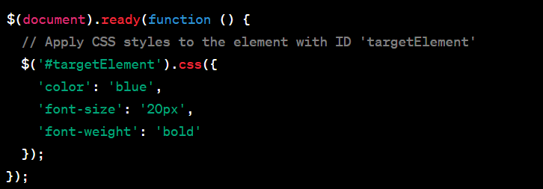

### 2. Adding and Removing Classes in jQuery:

You can use the **addClass()** and **removeClass()** methods to add and remove classes from HTML elements:  
  
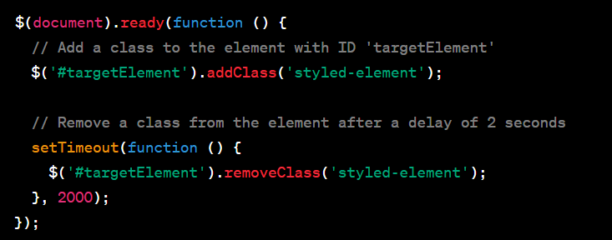

### 3. jQuery Animation:

jQuery provides various methods for creating animations. One common method is the **animate()** method. Here's an example:  
  
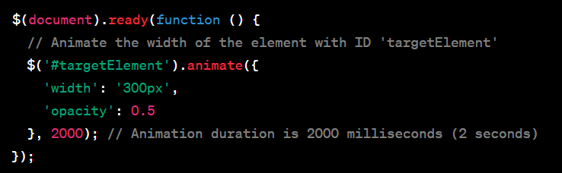

### Q3:- How to create slider with animation? ANS:- Creating a slider with animation typically involves using a combination of HTML, CSS, and JavaScript (including jQuery if desired). Here's a simple example of a basic image slider using HTML, CSS, and jQuery for animation: